
LA GRANDEE INTERNATIONAL COLLEGE
Simalchaur, Pokhara, Nepal

A Project Report
on
PhishGuard

Submitted to
Bachelor of Computer Application (BCA) Department
LA GRANDEE International College

In partial fulfillment of the requirements for the degree of Bachelor of Computer Application under Pokhara University

Submitted by
Name of the Student | PU Registration Number | Semester
Shital Dhakal | 2023-1-53-0345 | BCA-VI
Deven Shrestha | 2023-1-53-0325 | BCA- VI
Sandesh Bastola | 2023-1-53-0343 | BCA- VI

July, 2026

Student Declaration
We hereby declare that we are the only authors of this work and that no sources other than the listed here have been used in this work. We further confirm that the project work “PhishGuard” and hence this report is my original work and has not formed the basis for the award of any other degree or other similar titles.

____________________
Shital Dhakal
PU Reg. No. 2023-1-53-0345

____________________
Deven Shrestha
PU Reg. No. 2023-1-53-0325

____________________
Sandesh Bastola
PU Reg. No. 2023-1-53-0343

Date: July 13, 2026

Supervisor Acceptance
I, hereby, declare that the project entitled “PhishGuard” is done under my supervision by Shital Dhakal, Deven Shrestha and Sandesh Bastola during their 6th Semester in partial fulfillment of the requirements for the degree of Bachelor of Computer Application under Pokhara University is completed to my satisfaction and I recommend to be processed for final evaluation.

____________________
Mr. Ankit Poudyal
Program Coordinator
Date: July 13, 2026



Approval Certificate
We certify that we have examined this report entitled “PhishGuard” and are satisfied with the project defense. In our opinion, it is satisfactory in the scope and qualify as a project in partial fulfillment of the requirements for the degree of Bachelor of Computer Application under Pokhara University.

____________________ ____________________ __________________
Ankit Poudyal | Er. Sagun Devkota | Er. Kiran K.C.
Program Coordinator | External Examiner | Principal

Date: July 13, 2026

ABSTRACT
Email remains one of the primary vectors for cyberattacks, with phishing being a common technique used to steal credentials, distribute malware, and conduct financial fraud. Traditional email security solutions often rely on signature-based detection and basic filtering techniques, making them less effective against sophisticated phishing campaigns and emerging threats. To address this problem, this project presents PhishGuard, a web-based email analysis and threat visualization platform that automates the detection and analysis of suspicious emails. The system is developed using Python, Django, PostgreSQL, and machine learning techniques. It automatically retrieves emails from a monitored mailbox using IMAP, analyzes email authentication mechanisms (SPF, DKIM, and DMARC), extracts Indicators of Compromise (IOCs), verifies suspicious indicators through external threat intelligence services, classifies email content using a Multinomial Naive Bayes model, and calculates an overall risk score. The platform also provides an interactive dashboard for monitoring email threats and integrates the eSewa payment gateway to simulate software licensing transactions.
Testing results demonstrate that the system successfully performs automated email analysis, accurately classifies phishing emails, generates comprehensive threat reports, and provides intuitive visualizations for security analysts. By combining machine learning, threat intelligence, and automated risk assessment within a single platform, PhishGuard offers an efficient, secure, and user-friendly solution for improving organizational email security and supporting faster incident response.

ACKNOWLEDGEMENT
We would like to express our sincere gratitude to Mr. Ankit Poudyal, our project supervisor and program coordinator, for his invaluable advice, unwavering support, and technical expertise during the PhishGuard project's development. His helpful feedback, guidance, and constant encouragement have enabled us to complete our project successfully.
We also like to sincerely thank Er. Kiran K.C., Principal of LA GRANDEE International College, for providing a supportive academic environment, necessary resources, and encouragement that enabled us to carry out this project effectively.
Finally, we would like to express our sincere gratitude to our family, friends, and classmates for their unwavering support, inspiration, and insightful advice during this effort. Their encouragement and understanding have been a constant source of inspiration and have contributed significantly to the successful completion of this project.

Roles and Responsibility
Team Member | Project Role | Key Responsibilities & Deliverables
Deven Shrestha | Frontend & API Developer | • Developed the user interface (UI) and client-side logic.  • Built and integrated the APIs to connect the frontend with the database.
Shital Dhakal | Backend Developer | • Built and configured the server-side logic and database architecture  .• Handled data storage, processing, and backend security.
Sandesh Bastola | UI Designer & System Analyst | • Researched and designed the user interface (UI) layouts and user flow  .• Provided functional requirements and design suggestions for the frontend.

Table of Contents
CHAPTER 1: INTRODUCTION 1
1.1 Background 1
1.2 Objectives 2
1.3 Purpose, Scope, and Applicability 2
1.3.1 Purpose 2
1.3.2 Scope 2
1.3.3 Applicability 4
1.4 Achievements 4
1.5 Organization of Report 5
CHAPTER 2: SURVEY OF TECHNOLOGIES 7
2.1 Gmail Spam Filter 7
2.2 KnowBe4 PhishER 8
CHAPTER 3: REQUIREMENTS AND ANALYSIS 9
3.1 Problem Definition 9
3.2 Requirements Specification 9
3.2.1 Functional Requirements 9
3.2.2 Non-Functional Requirements 11
3.3 Planning and Scheduling 13
3.3.1 Methodology Steps Followed 13
3.4 Software and Hardware Requirements 15
3.5 Preliminary Product Description 16
3.6 Conceptual Models 17
3.6.1 System Context Diagram 17
3.6.2 Use Case Diagram 19
3.6.3 Entity-Relationship (ER) Diagram 20
3.6.4 UML Class Diagram 22
3.6.5 Sequence Diagram 23
CHAPTER 4: DESIGN 24
4.1 Introduction 24
4.2 System Design 24
4.3 Database Design 25
4.4 Interface Design 28
4.4.1 UI/UX Design Principles 29
4.4.2 Core Screen Layouts 29
4.5 Summary 32
CHAPTER 5: IMPLEMENTATION AND TESTING 33
5.1 Implementation Approaches 33
5.2 Coding Details and Code Efficiency 34
5.2.1 Dynamic Risk Scoring Algorithm 34
5.2.2 IOC Caching Strategy 35
5.2.3 Code Efficiency 35
5.3 Testing Approach 36
5.3.1 Unit Testing 36
5.3.2 Integration Testing 37
5.3.3 Beta Testing 37
5.4 Modifications and Improvements 37
5.4.1 Optimized Threat Intelligence Lookup 37
5.4.2 Enhanced Risk Scoring Strategy 38
5.4.3 Machine Learning Model Improvement 38
5.5 Test Cases 39
CHAPTER 6: RESULTS AND DISCUSSION 41
6.1 Test Reports 41
6.2 User Documentation 42
6.2.1 Guide for Employees: Verifying Email Security 42
6.2.2 Guide for Security Analysts: Investigating Email Threats 43
CHAPTER 7: CONCLUSIONS 44
7.1 Conclusion 44
7.1.1 Significance of the System 44
7.2 Limitations of the System 44
7.3 Future Scope of the Project 45
REFERENCES 47

List of Figures
Figure 3.3 1- Gantt Chart 15
Figure 3.6.1 1- Level 0 DFD 17
Figure 3.6.1 2 - Level 1 DFD 18
Figure 3.6.1 3 - Level 2 DFD 19
Figure 3.6.2 - UML Use Case Diagram 20
Figure 3.6.3 - Entity-Relationship Diagram 21
Figure 3.6.4 - UML Class Diagram 22
Figure 4.2.1 – MVT Architecture Diagram 25
Figure 4.4.2.1 Analyst Dashboard interface. 30
Figure 4.4.2.2 User Management interface. 30
Figure 4.4.2.3 Dashboard interface. 31
Figure 6.1.1 - Final Analyst Threat Operations Dashboard UI 42
Figure 6.1.2 - Admin User Governance Dashboard UI 42

List of Abbreviations
APWG | Anti-Phishing Working Group
BCA | Bachelor of Computer Application
CERT | Computer Emergency Response Team
DFD | Data Flow Diagram
DKIM | DomainKeys Identified Mail
DMARC | Domain-based Message Authentication, Reporting, and Conformance
DNS | Domain Name System
EDR | Endpoint Detection and Response
ER | Entity-Relationship
IMAP | Internet Message Access Protocol
IOC | Indicator of Compromise
MISP | Malware Information Sharing Platform
MVC | Model-View-Controller
MVT | Model-View-Template
ORM | Object-Relational Mapper / Object-Relational Mapping
PU | Pokhara University
RBAC | Role-Based Access Control
SIEM | Security Information and Event Management
SME | Small and Medium-Sized Enterprises
SOAR | Security Orchestration, Automation, and Response
SOC | Security Operations Center
SPF | Sender Policy Framework
UAT | User Acceptance Testing

List of Tables

Table 3.2.1 – Performance Metrics 12
Table 3.4.1 – System Requirements 16
Table 4.3.1 – User Schema ‘accounts_user’ 26
Table 4.3.2 – MailBox Schema (mailbox_mailbox) 27
Table 4.3.3 – EmailRecord Schema (mailbox_emailrecord) 27
Table 4.3.4 – EmailAttachment Schema (mailbox_emailattachment) 28
Table 4.3.5 – IOC Schema (analyzer_ioc) 28
Table 4.3.6 – AnalysisReport Schema (analyzer_analysisreport) 29
Table 5.5.1 – Core Module Test Cases 38

CHAPTER 1: INTRODUCTION

1.1 Background
In today’s world, e-mail is still the most common form of communication in businesses, where around 376.4 billion e-mails are exchanged globally on a daily basis in 2025 (Statista, 2026). This figure will keep increasing in the upcoming years. However, this widespread adoption has made email the most exploited attack vector in cybersecurity. According to Anti-Phishing Working Group (APWG), there have been over 4.8 million phishing attempts reported across the globe in 2024, thereby demonstrating the growing number and complexity of phishing attacks that are increasingly being launched against individuals and organizations, thus indicating an increased number of email threats against organizations. Phishing attacks are a form of social engineering where malicious actors impersonate trusted entities such as banks, service providers, or internal departments to deceive recipients into revealing sensitive information, clicking on malicious links, or downloading harmful attachments (Chiew et al., 2018). These attacks often bypass basic spam filters by using sophisticated techniques such as lookalike domains, URL obfuscation, urgency-driven language, and legitimate email authentication through compromised or free email accounts (Nightingale, 2017). To address these challenges, PhishGuard is a web-based application built using the Django framework (Python) that provides a centralized platform for submitting, analyzing, classifying, and visualizing email threats. The solution automates the entire process of email investigation, which includes email header extraction, IOCs extraction, URL and keyword analysis to check phishing patterns, classification of emails in threat categories, and calculation of risk scores saving the time spent on the analysis. The solution is also built using Pandas, Matplotlib, and Chart.js to analyze and visualize the data.

1.2 Objectives
The primary objective of PhishGuard is to develop an automated and intelligent system for detecting, analyzing, and managing email-based phishing threats. The specific objectives are:
- Build a web platform to retrieve reported emails via IMAP, view detailed reports, and monitor trends..
- Extract details from emails (URLs, IPs, domains, and attachment hashes) and check them against MalwareBazar, Google Safe Browsing, VirusTotal, and AbuseIPDB.
- Train a model to classify emails, and use a weighted score (combining authentication, keywords, reputation, and ML predictions) to give a final verdict..

1.3 Purpose, Scope, and Applicability

1.3.1 Purpose
The project focuses on achieving the following objectives:
- Develop a web-based email analysis platform that automatically retrieves and processes emails forwarded from employee mailboxes to a centralized reporting mailbox for analysis.
- Implement an automated email analysis engine that parses email headers, extracts Indicators of Compromise (IOCs) such as URLs, IP addresses, domains, and attachment hashes, and detects phishing-related keywords and social engineering patterns within email content.
- Integrate external threat intelligence services to verify the reputation of extracted IOCs and improve phishing detection.
- Develop a machine learning model to classify emails based on their phishing probability.
- Design a weighted risk scoring mechanism to generate an overall risk score and security verdict for each analyzed email.
- Provide an interactive dashboard that enables security analysts to monitor threats, review analysis reports, and visualize phishing trends.

1.3.2 Scope
The scope of the PhishGuard project encompasses the design and development of a web-based platform for automated phishing email detection, analysis, and reporting. The system focuses on assisting security analysts by automating the inspection of reported emails and providing actionable threat intelligence. The project covers the following functional areas:
- Email Retrieval: The system automatically retrieves reported emails from a centralized monitoring mailbox using the Internet Message Access Protocol (IMAP), eliminating the need for manual email submission.
- Email Analysis: The platform extracts and analyzes email headers, body content, and attachments to identify Indicators of Compromise (IOCs), verify email authentication mechanisms (SPF, DKIM, and DMARC), and detect phishing-related keywords and suspicious patterns.
- Threat Intelligence Integration: The system integrates with external threat intelligence services, including VirusTotal and AbuseIPDB, to verify the reputation of extracted URLs, IP addresses, domains, and file hashes.
- Machine Learning-Based Classification: A Naive Bayes machine learning model is used to classify emails as legitimate or phishing based on their textual content and learned phishing patterns.
- Risk Scoring and Threat Classification: The platform combines authentication analysis, IOC reputation, keyword detection, and machine learning predictions to generate an overall risk score and classify emails as Clean, Spam, or Phishing. Detected phishing emails are further categorized into common phishing types to provide additional context for security analysts.
- Report Management and Visualization: The system stores analysis results in a PostgreSQL database and provides an interactive web dashboard that enables administrators to review reports, visualize phishing trends and search historical analyses
Out of Scope: To maintain a well-defined project scope, the following functionalities are excluded from the current version of PhishGuard:
- Automatic quarantine, deletion, or blocking of malicious emails from users' mailboxes.
- Manual submission of email files (such as .eml or .msg) or manual pasting of raw email headers through the web interface.
- Native mobile applications for Android or iOS platforms.
- Automated integration with enterprise firewalls, proxy servers, DNS servers, or email gateways for network-level blocking of malicious domains or IP addresses.
- Real-time endpoint monitoring, endpoint detection and response (EDR), or network intrusion detection capabilities.

1.3.3 Applicability
The PhishGuard system is designed to support organizations and educational institutions by providing an automated solution for email threat detection and analysis. It is applicable in the following environments:
- Small and Medium-Sized Enterprises (SMEs): Organizations can deploy PhishGuard to enhance email security by automatically analyzing incoming emails for phishing threats, suspicious links, malicious attachments, and other Indicators of Compromise (IOCs).
- Security Operations Centers (SOCs) and Cybersecurity Teams: Security analysts can use the platform to investigate reported emails, review detailed analysis reports, assess risk scores, and make informed decisions during incident response activities.
- Educational Institutions and Research: Universities, colleges, and cybersecurity researchers can use PhishGuard as a practical learning and research platform to study email security, phishing detection techniques, email authentication mechanisms (SPF, DKIM, and DMARC), threat intelligence, and machine learning-based classification.
- General Employees and Email Users: Employees within an organization benefit from automated post-delivery email analysis, enabling early detection of phishing attempts and reducing the risk of credential theft, malware infection, and other social engineering attacks.
Overall, PhishGuard is suitable for organizations seeking to strengthen email security, improve phishing detection capabilities, and provide security analysts with a centralized platform for threat analysis and reporting.

1.4 Achievements
The successful completion of the PhishGuard project resulted in the development of a comprehensive web-based platform for automated phishing email detection, analysis, and reporting. The major achievements of the project are as follows:
- High-Accuracy Email Classification: Developed and trained a Naive Bayes machine learning model using the Zero-Day Phishing Emails Corpus, achieving an overall classification accuracy of 98.73% and a precision of 97.55%, enabling reliable detection of phishing emails.
- Multi-Layer Threat Detection: Implemented a hybrid detection approach that combines email authentication analysis (SPF, DKIM, and DMARC), keyword analysis, IOC extraction, external threat intelligence, and machine learning classification to improve detection accuracy and reduce false positives.
- Automated Email Processing: Successfully developed an IMAP-based email ingestion mechanism that automatically retrieves and analyzes emails from a centralized reporting mailbox without requiring manual user intervention.
- Risk Scoring and Threat Classification: Designed a weighted risk scoring engine that aggregates multiple analysis results to generate an overall risk score and classify emails as Clean, Spam, or Phishing, with further categorizing phishing emails into common phishing attack types.
- Threat Intelligence Integration: Integrated VirusTotal, MalwareBazar, URLHaus and AbuseIPDB APIs to validate the reputation of extracted URLs, IP addresses, domains, and file hashes, providing additional evidence during threat analysis.
- Centralized Report Management: Developed a PostgreSQL-backed reporting system that securely stores email records, extracted Indicators of Compromise (IOCs), and detailed analysis reports, supporting efficient investigation and auditability.
- Interactive Dashboard and Visualization: Built a web-based dashboard that enables administrators to monitor phishing trends, review detailed analysis reports and search historical records

1.5 Organization of Report
This report is organized into seven chapters, each addressing a specific aspect of the PhishGuard project, from the problem background to the final implementation and evaluation. A brief overview of each chapter is presented below:
- Chapter 1: Introduction presents the project background, objectives, purpose, scope, applicability, achievements, and the overall organization of the report.
- Chapter 2: Survey of Technologies reviews related studies, existing phishing detection solutions, and the technologies, tools, and techniques relevant to the development of the proposed system.
- Chapter 3: Requirements and Analysis describes the problem definition, functional and non-functional requirements, project planning and scheduling, software and hardware requirements, preliminary product description, and conceptual models of the system.
- Chapter 4: Design presents the overall system architecture, database design, and user interface design, illustrating how the different components of the system interact to achieve the project objectives.
- Chapter 5: Implementation and Testing discusses the implementation methodology, coding approaches, code efficiency, and the testing strategies adopted to validate the functionality and reliability of the system, including unit, integration, and beta testing.
- Chapter 6: Results and Discussion presents the system evaluation, test results, performance analysis, and user documentation, demonstrating the effectiveness of the developed application.
- Chapter 7: Conclusion summarizes the overall project, highlights the significance of the developed system, discusses its limitations, and outlines potential directions for future enhancements.

CHAPTER 2: SURVEY OF TECHNOLOGIES
Email phishing has become one of the most significant cybersecurity threats affecting individuals, businesses, and government organizations. As email continues to be the primary medium for digital communication, numerous commercial and enterprise email security solutions have been developed to detect spam, phishing attacks, malicious attachments, and other email-based threats. These solutions commonly utilize machine learning, email authentication protocols, reputation-based threat intelligence, and security automation to improve detection accuracy and reduce security risks.
Studying existing email security systems helps identify their strengths and limitations while providing valuable insights for developing improved solutions. Although many commercial products offer effective phishing detection capabilities, they often provide limited threat visibility, require expensive enterprise subscriptions, or depend on manual user reporting before analysis can begin. The following sections discuss two widely used email security solutions relevant to this project.

2.1 Gmail Spam Filter
The Gmail Spam Filter is Google's built-in email security service available in Gmail and Google Workspace. It automatically analyzes incoming emails using machine learning models, sender reputation, and email authentication mechanisms such as Sender Policy Framework (SPF), DomainKeys Identified Mail (DKIM), and Domain-based Message Authentication, Reporting, and Conformance (DMARC). The system also examines embedded URLs and email attachments using Google's threat intelligence services to detect known phishing and malware campaigns (Google Cloud, 2023).
Strengths
- Provides automatic spam and phishing detection without user intervention.
- Verifies sender authenticity using SPF, DKIM, and DMARC.
- Detects malicious links and attachments using Google's threat intelligence services.
- Continuously improves detection accuracy using machine learning.
Weaknesses
- Primarily provides binary classification (Spam or Not Spam).
- Does not generate a detailed risk score for each email.
- Offers limited explanation of why an email was classified as suspicious.
- Does not categorize phishing emails into specific attack types for security investigations.

2.2 KnowBe4 PhishER
KnowBe4 PhishER is an enterprise Security Orchestration, Automation, and Response (SOAR) platform designed to help security teams manage and investigate user-reported phishing emails. The platform automatically categorizes reported emails, prioritizes security incidents, and assists analysts in responding efficiently to phishing attacks. It also integrates with other enterprise security solutions to streamline incident response workflows (KnowBe4, 2024).
Strengths
- Automates phishing email triage and incident management.
- Prioritizes suspicious emails for faster investigation.
- Supports enterprise security workflows and automation.
- Provides centralized management of reported phishing emails.
Weaknesses
- Requires commercial licensing, making it expensive for small organizations.
- Relies primarily on users manually reporting suspicious emails.
- Less suitable for educational institutions and small businesses with limited budgets.
- Provides limited flexibility for customization because it is a proprietary enterprise platform.

CHAPTER 3: REQUIREMENTS AND ANALYSIS

3.1 Problem Definition
Although several email security solutions are available in the current market, many are either enterprise-grade platforms that are expensive and complex for small and medium-sized organizations or basic email filtering systems that provide limited threat analysis. Enterprise solutions often require costly licensing, specialized administration, and extensive configuration, making them unsuitable for organizations with limited financial and technical resources.
On the other hand, built-in email spam filters primarily classify emails as either spam or legitimate without providing detailed information about the nature of the threat, overall risk level, or supporting evidence used during the analysis. Most existing systems also offer limited visibility into phishing trends, historical reports, and centralized threat monitoring, making it difficult for security teams to investigate and manage email-based attacks efficiently.
These limitations create a clear need for a cost-effective, automated, and centralized email threat analysis platform that combines multiple detection techniques, provides detailed risk assessment, and presents actionable information through an intuitive web interface. The proposed PhishGuard system addresses these challenges by offering automated email analysis, multi-layer threat detection, risk scoring, and centralized reporting within a single web-based platform.

3.2 Requirements Specification
This section describes the functional and non-functional requirements of the PhishGuard system. Functional requirements define the core features that the system must provide, whereas non-functional requirements specify the quality attributes and operational constraints that the system must satisfy.

3.2.1 Functional Requirements
- Email Processing Module
FR-EP-001: Email Retrieval
- The system shall retrieve emails automatically from a configured mailbox using the IMAP protocol.
- The system shall store newly retrieved emails for further analysis.
FR-EP-002: Email Parsing
- The system shall extract email headers, message content, and attachment information.
- The system shall separate plain text and HTML email content for processing.
- Threat Analysis Module
FR-TA-001: Email Authentication Analysis
- The system shall verify email authentication mechanisms, including SPF, DKIM, and DMARC.
- The system shall identify potential sender spoofing attempts based on email header analysis.
FR-TA-002: Indicator of Compromise (IOC) Extraction
- The system shall extract URLs, IP addresses, domains, email addresses, and attachment hashes from emails.
- The system shall store the extracted IOCs for further verification.
FR-TA-003: Threat Intelligence Verification
- The system shall verify extracted IOCs using external threat intelligence services.
- The system shall identify malicious or suspicious URLs, IP addresses, domains, and file hashes.
FR-TA-004: Keyword Analysis
- The system shall analyze the email subject and body for phishing-related keywords and suspicious language.
- The system shall identify common social engineering patterns within email content.
- Machine Learning Module
FR-ML-001: Email Preprocessing
- The system shall preprocess email text before classification.
- The system shall prepare the extracted text for machine learning analysis.
FR-ML-002: Email Classification
- The system shall classify emails as legitimate or phishing using a trained machine learning model.
- The system shall generate a phishing probability score for each analyzed email.
- Risk Assessment Module
FR-RA-001: Risk Score Calculation
- The system shall calculate an overall risk score by combining results from multiple analysis modules.
- The system shall generate a risk score ranging from 0 to 100.
FR-RA-002: Threat Classification
- The system shall classify analyzed emails as Clean, Spam, or Phishing.
- The system shall categorize phishing emails into predefined phishing attack types whenever applicable.
FR-RA-003: Report Generation
- The system shall generate a detailed analysis report for every processed email.
- The system shall store analysis results and verdicts in the database.
- Dashboard and Report Management Module
FR-DM-001: User Authentication
- The system shall authenticate authorized users before granting access.
- The system shall provide role-based access control for employees and security analysts.
FR-DM-002: Dashboard Visualization
- The system shall display summary statistics, phishing trends, severity distributions, and risk metrics through an interactive dashboard.
FR-DM-003: Report Management
- The system shall allow analysts to search, filter, and review analysis reports.
- The system shall allow analysts to update verdicts and add investigation notes.

3.2.2 Non-Functional Requirements
Non-functional requirements define the quality attributes and operational constraints that the PhishGuard system must satisfy to ensure reliable, secure, efficient, and maintainable operation.

1. Performance Metrics
Table 3.2.1 – Performance Metrics
Requirement | Target
NFR-PM-001: Email Retrieval Time | < 3.0 seconds
NFR-PM-002: Machine Learning Classification | < 150 milliseconds
NFR-PM-003: Threat Intelligence Response Time | ≤ 15 seconds
NFR-PM-004: Dashboard Load Time | < 2.0 seconds
NFR-PM-005: Database Query Response Time | < 50 milliseconds
2. Security
NFR-S-001: Data Protection
- Communication between users, the web application, mail servers, and external services shall be encrypted using secure communication protocols.
NFR-S-002: User Authentication
- The system shall securely store user credentials using industry-standard password hashing techniques and enforce secure authentication.
NFR-S-003: Access Control
- The system shall implement role-based access control (RBAC) to ensure that employees and security analysts can only access resources permitted by their roles.
NFR-S-004: Input Validation
- The system shall validate all user inputs to minimize the risk of unauthorized access and common web application attacks.
3. Reliability
NFR-R-001: Data Reliability
- The system shall ensure that email records and analysis reports are stored reliably without data loss.
4. Scalability
NFR-S-001: Modularity
- The system shall support future enhancements through a modular software architecture that allows new detection modules and machine learning models to be integrated with minimal changes.
NFR-S-002: Performance Under Load
- The system shall maintain acceptable performance as the number of stored emails and analysis reports increases.
5. Usability
NFR-U-001: User Friendly Interface
- The system shall provide a responsive and user-friendly web interface that enables users to navigate the system with minimal training.
NFR-U-002: Clear Information Display
- The dashboard shall present threat statistics, risk scores, and analysis reports in a clear and understandable format.
6. Maintainability
NFR-M-001: Code Documentation
- The system shall include adequate documentation and well-organized source code to support future development and maintenance activities.

3.3 Planning and Scheduling
The PhishGuard project was developed using the Watefall Software Development Methodology. This methodology was selected because it supports a structured, linear, and phase-based approach throughout the software development lifecycle. The project was divided into distinct, sequential phases—Requirements, Design, Implementation, Verification, and Maintenance—ensuring that each stage was fully completed, documented, and approved before progressing to the next.

3.3.1 Methodology Steps Followed
Step 1: Requirement Analysis
The project objectives, functional requirements, non-functional requirements, and system constraints were identified. Existing email security solutions were studied, and the overall project scope was defined.
Step 2: System Design
The overall system architecture, database schema, module interactions, and user interface wireframes were designed. The project structure and development environment were also prepared.
Step 3: Email Processing Module
The email retrieval mechanism and email parsing module were developed to automatically retrieve, process, and store incoming emails for further analysis.
Step 4: Threat Detection Module
The email authentication analysis, IOC extraction, keyword detection, and external threat intelligence integration modules were implemented to identify potential phishing indicators.
Step 5: Machine Learning Module
The phishing email dataset was prepared and preprocessed. A Naive Bayes machine learning model was trained, evaluated, and integrated into the system for automated email classification.
Step 6: Risk Assessment Module
The weighted risk scoring engine was developed to combine authentication analysis, keyword detection, IOC reputation, and machine learning predictions into a unified risk score and final threat verdict.
Step 7: Dashboard Development
The web-based dashboard, reporting interface, data visualization components, and report management features were implemented to provide users with centralized monitoring and analysis capabilities.
Step 8: Testing and Final Review
Comprehensive unit testing, integration testing, and system testing were performed to verify the functionality, reliability, and performance of the system. Identified issues were resolved, and the final project documentation was completed.
Project Schedule (Gantt Chart)
Below is the Gantt chart representing the timeline of the phases over the project duration.
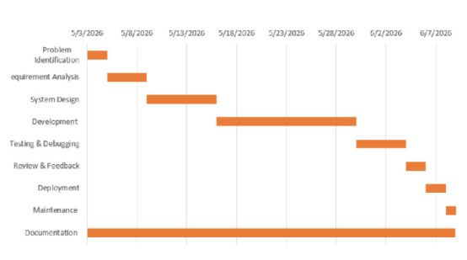
Figure 3.3 1- Gantt Chart

3.4 Software and Hardware Requirements
The successful development and deployment of the PhishGuard system require appropriate hardware and software resources. The requirements are categorized into the Development Environment, used during system development, and the Deployment/Client Environment, used for hosting the application and accessing it through a web browser.
Table 3.4.1 – System Requirements
Component | Development Environment | Deployment / Client Environment
Hardware | Intel Core i5 / AMD Ryzen 5 (or equivalent), minimum 8 GB RAM, 256 GB SSD | Hosting Server: Dual-Core Processor, minimum 2 GB RAM, 20 GB SSD. Client: Any desktop, laptop, or mobile device with internet connectivity.
Operating System | Windows 10/11, macOS, or Linux | Hosting Server: Ubuntu Linux (or equivalent). Client: Any operating system with a modern web browser.
Software / Tools | Visual Studio Code, Git, PostgreSQL, pgAdmin 4, Postman | Python 3.10+, PostgreSQL Database, Google Chrome, Mozilla Firefox, Microsoft Edge, or Safari
Technology Stack | Python 3.10+, Django 4.x, PostgreSQL, scikit-learn, Pandas, NLTK, Matplotlib, Chart.js | Django, PostgreSQL, HTML5, CSS3, JavaScript, Chart.js

3.5 Preliminary Product Description
The PhishGuard system is a web-based application that helps organizations detect and analyze phishing emails automatically. When the system is deployed within an organization, it continuously monitors a centralized reporting mailbox for newly received emails. Employees do not need to manually upload or submit suspicious emails, as the system retrieves them automatically for analysis.
When an employee logs into the PhishGuard web application using their assigned credentials, they are redirected to their personalized dashboard. The dashboard displays the emails that have been analyzed by the system, along with their corresponding risk scores and security verdicts, such as Safe, Suspicious, or Malicious. If the employee selects a particular email, the system displays a summary explaining why the email was classified with that verdict, allowing the employee to better understand potential phishing threats.
Security Analysts log into the administrative dashboard using their authorized accounts. After successful authentication, they can view all analyzed emails within the organization through a centralized interface. The dashboard provides graphical summaries of phishing trends, threat categories, and overall security statistics. Analysts can search and filter reports, review detailed analysis results, update investigation notes, and modify verdicts when necessary.
If an analyst opens a suspicious email, the system presents a detailed analysis report containing email authentication results, extracted Indicators of Compromise (IOCs), threat intelligence findings, machine learning classification results, and the overall risk score. Based on this information, the analyst can complete the investigation. Overall, the PhishGuard system provides a simple and centralized workflow that enables employees to view analyzed emails while allowing security analysts to efficiently investigate, manage, and monitor phishing threats across the organization.

3.6 Conceptual Models
This section presents the structural and behavioral models of the PhishGuard application. These conceptual diagrams map out the system boundaries, data flow mechanics, user interactions, and relational database schema design.

3.6.1 System Context Diagram
- Level 0 DFD (Context Diagram)
The Context Diagram illustrates the highest-level operational view of the PhishGuard system. It represents the application as a single process interacting with external entities: the Mail Server, the General Employee, and the Security Analyst. It models the inputs (such as raw email feeds and payment tokens) and outputs (such as dashboard visualizations, verdicts, and CSV reports) that define the boundaries of the platform.
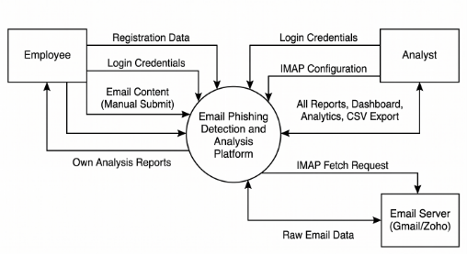
Figure 3.6.1 1- Level 0 DFD
- Data Flow Diagram (Level 1 DFD)
The Level 1 Data Flow Diagram presents the internal processes of the PhishGuard system in greater detail. It includes user authentication, email ingestion, email analysis, report management, and dashboard generation. The diagram also shows the interaction with data stores such as user records, email records, IOC databases, analysis reports, and mailbox configurations.
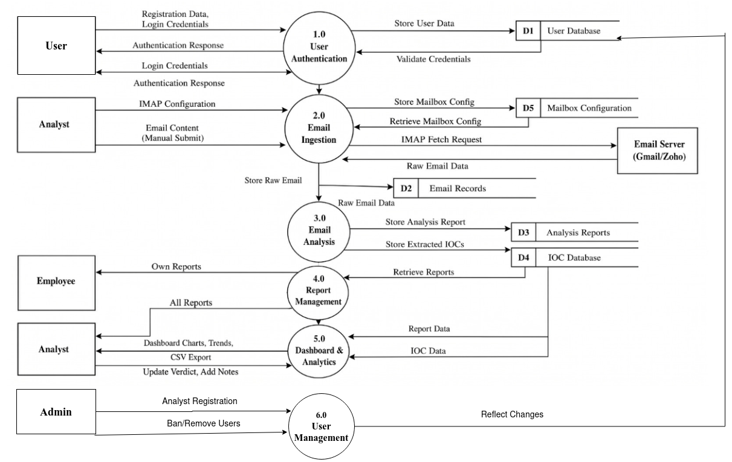
Figure 3.6.1 2 - Level 1 DFD

- Data Flow Diagram (Level 2 DFD)
The Level 2 Data Flow Diagram presents the detailed decomposition of Process 3.0 (Email Analysis) in the PhishGuard system. It illustrates the sequence of sub-processes involved in parsing email content, analyzing authentication headers, extracting Indicators of Compromise (IOCs), detecting phishing keywords, performing threat intelligence lookups, machine learning classification, calculating the overall risk score, and generating analysis reports. The diagram also shows the interaction with data stores such as Email Records, IOC Database, and Analysis Reports, along with external threat intelligence services including Google Safe Browsing, URLhaus, AbuseIPDB, and VirusTotal.
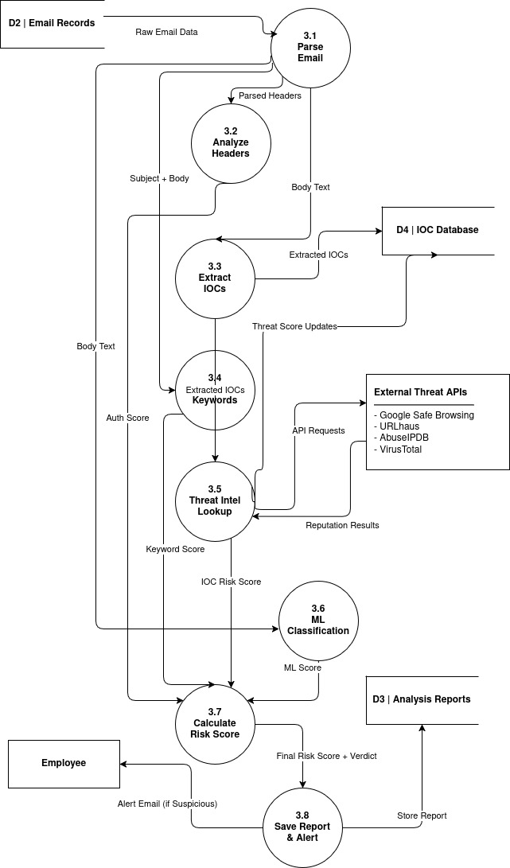
Figure 3.6.1 3 - Level 2 DFD

3.6.2 Use Case Diagram
The Use Case Diagram illustrates the interactions between the Employee and Analyst roles and the PhishGuard system. Employees can register, log in, submit emails for analysis, and view their analysis reports. Analysts can configure IMAP mailboxes, scan mailboxes, review reports, update verdicts and notes and view dashboards and analytics. The diagram provides a high-level overview of the system's functionality and user interactions.
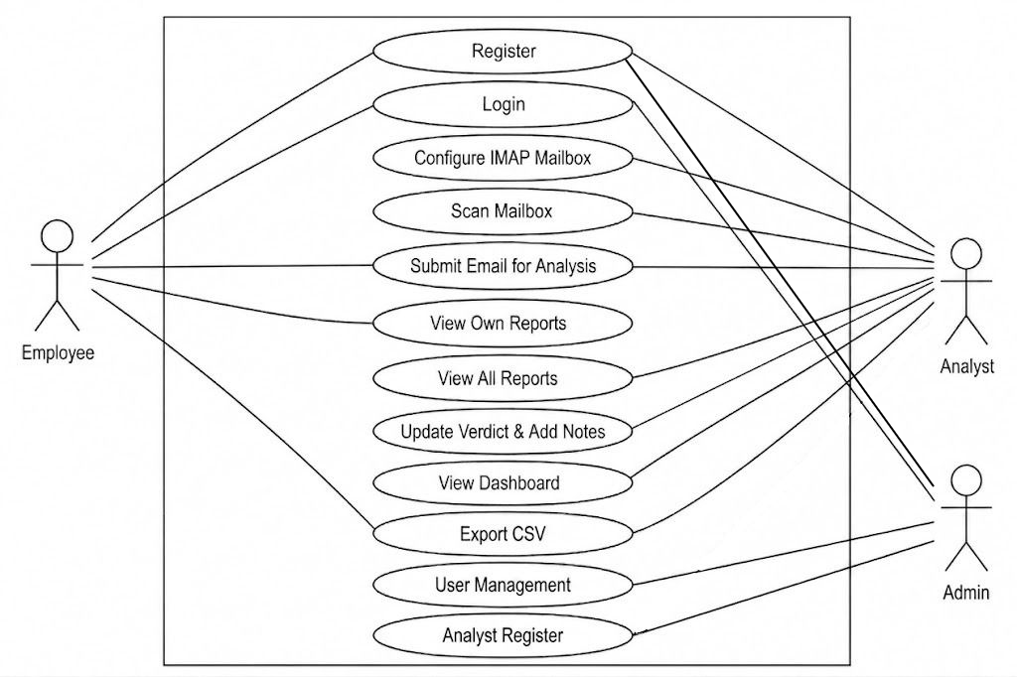
Figure 3.6.2 - UML Use Case Diagram

3.6.3 Entity-Relationship (ER) Diagram
The Entity-Relationship Diagram outlines the database design of the platform, detailing the database tables (MailBox, EmailRecord, EmailAttachment, IOC, and AnalysisReport) and their relational integrity. It enforces critical constraints, including the strict one-to-one mapping between email records and their analysis reports, and the one-to-many relationship linking emails to file attachments.
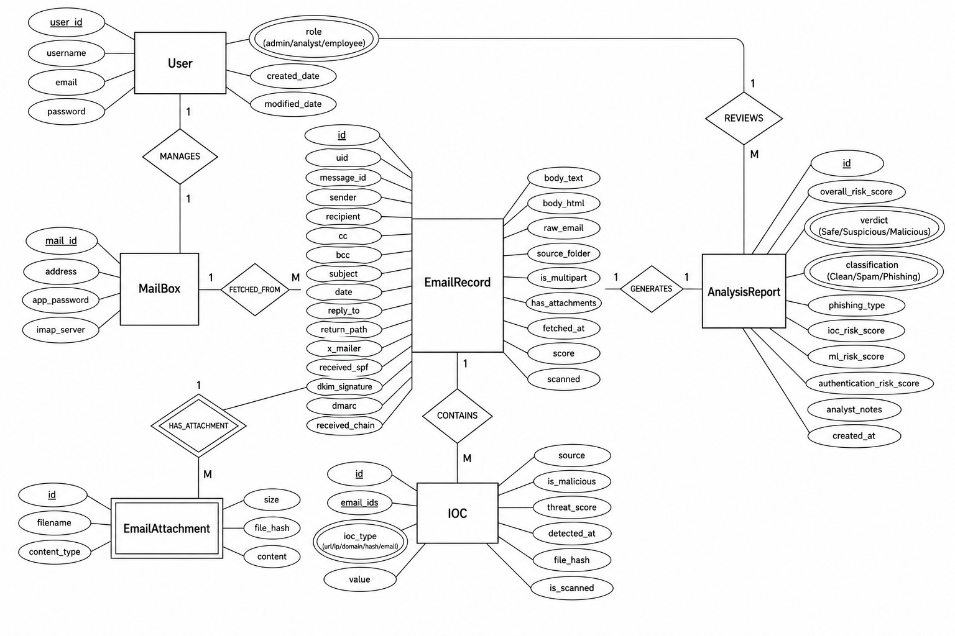
Figure 3.6.3 - Entity-Relationship Diagram

3.6.4 UML Class Diagram
The UML Class Diagram illustrates the static structure of the PhishGuard system by showing its main classes, attributes, methods, and relationships. It includes key entities such as User, MailBoxConfig, EmailRecord, IOC, and AnalysisReport, demonstrating how they interact to support email retrieval, phishing analysis, IOC extraction, and report generation. This design promotes a modular and maintainable system architecture.
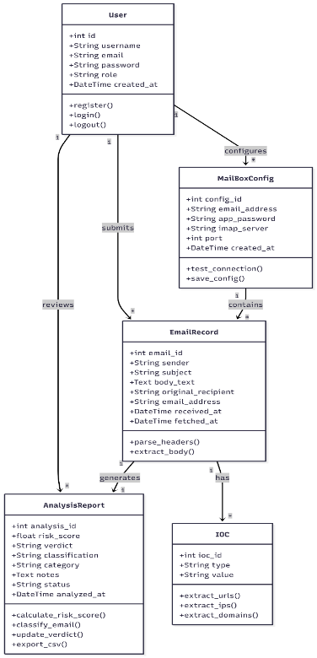

Figure 3.6.4 - UML Class Diagram

3.6.5 Sequence Diagram
The sequence diagram illustrates the interaction between the user and the major components of the PhishGuard system during the email analysis process. When a user initiates the analysis of an email, the dashboard retrieves the selected email record from the database and passes it to the email parser. The parsed email is then processed sequentially by the header analyzer, IOC extractor, keyword detector, threat intelligence module, and machine learning classifier. The outputs from these modules are forwarded to the risk scoring component, which calculates the overall risk score, determines the final verdict, and classifies the email. Finally, the analysis report is stored in the database, the email status is updated as scanned, and the dashboard displays the final risk score and verdict to the user.
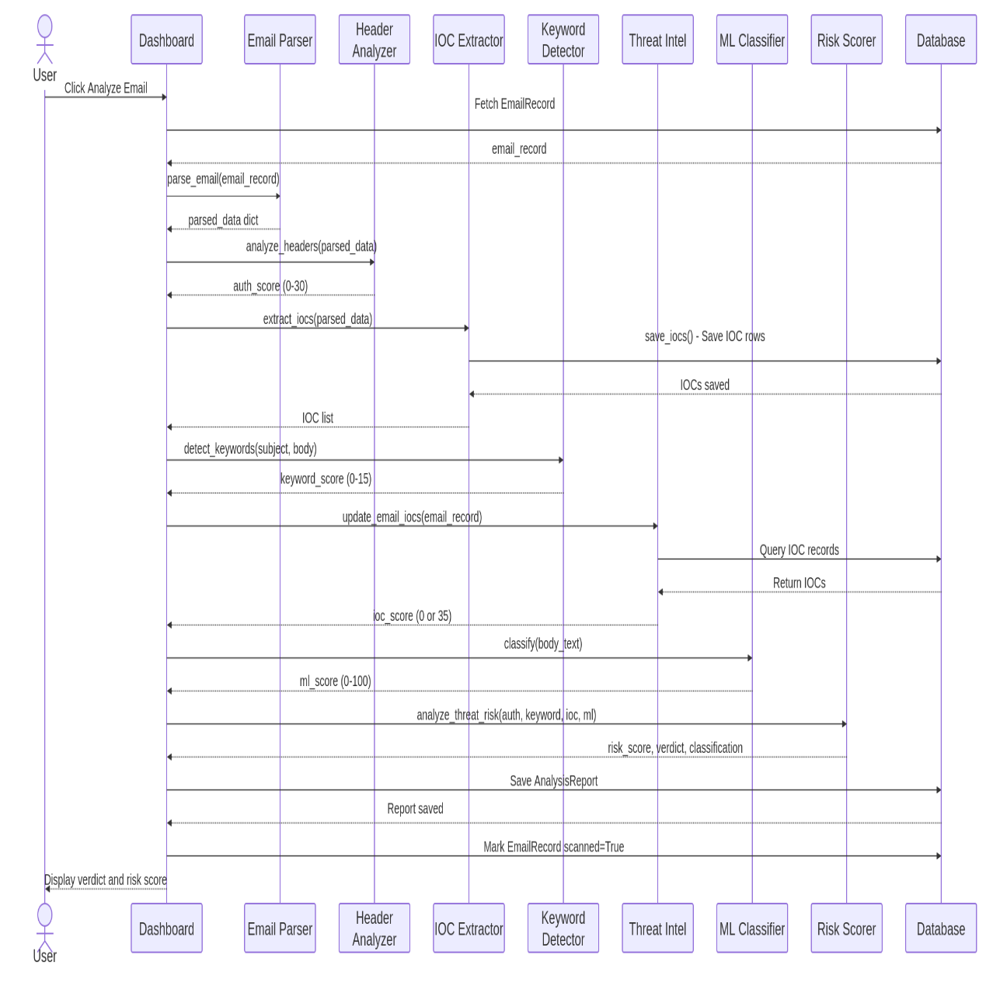Figure 3.6.5 - UML Class Diagram

CHAPTER 4: DESIGN

4.1 Introduction
The design phase serves as the bridge between the system requirements presented in Chapter 3 and the implementation of the PhishGuard system. During this phase, the conceptual requirements are transformed into technical designs that define the overall structure and operation of the application. This chapter presents the system architecture, database design, and user interface design, illustrating how the various components interact to achieve the project objectives. These design specifications provide a clear blueprint for implementing a secure, scalable, and maintainable phishing email analysis platform.

4.2 System Design
The PhishGuard system follows the Model-View-Template (MVT) architectural pattern, which is Django's native implementation of the Model-View-Controller (MVC) architecture. In addition, the system adopts a service-oriented backend architecture, where independent service modules perform specialized email analysis tasks. This modular design improves maintainability, scalability, and code reusability by separating the presentation layer, business logic, and data management.
- Model: The Model represents the data layer of the application. It consists of Django ORM classes that map directly to PostgreSQL database tables, such as EmailRecord, IOC, and AnalysisReport. The Model is responsible for managing data storage, enforcing validation rules, and handling database operations.
- View: The View acts as the application's processing layer. It receives HTTP requests from users, coordinates the execution of the required business logic, invokes the appropriate backend service modules (such as email parsing, header analysis, IOC extraction, keyword detection, threat intelligence verification, machine learning classification, and risk scoring), retrieves data from the database through the Models, and returns the processed information to the Templates.
- Template: The Template represents the presentation layer of the system. It is implemented using Django Templates together with HTML5, CSS3, and JavaScript to generate dynamic web pages. The Template layer displays interactive dashboards, email analysis reports, threat statistics, and visualizations using Apache ECharts, Bootstrap 5, SweetAlert2, and Toastr, providing an intuitive user interface for both Security Analysts and General Employees.
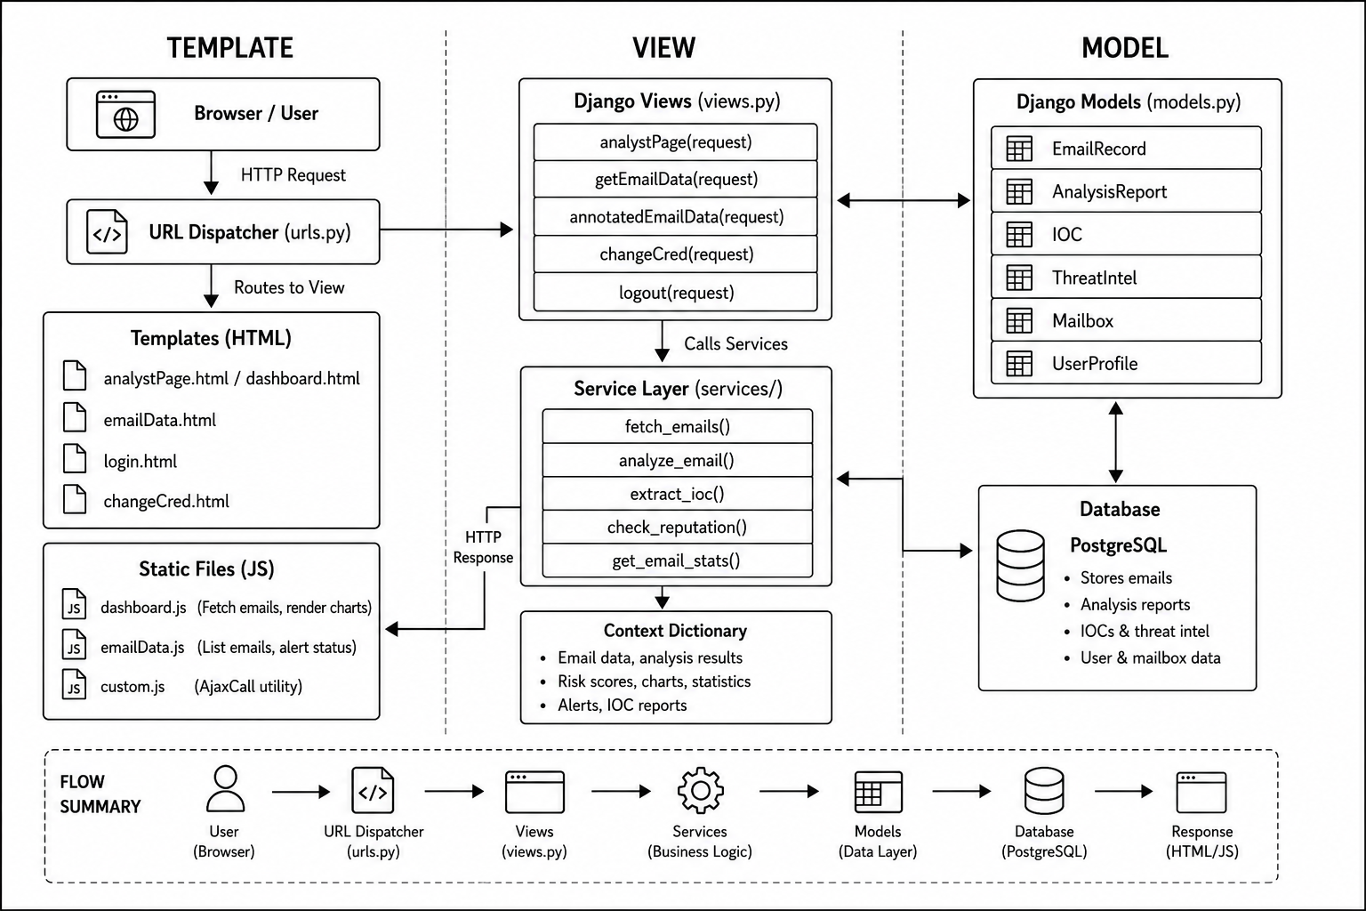Figure 4.2.1 – MVT Architecture Diagram

4.3 Database Design
The PhishGuard system uses a relational database implemented in PostgreSQL and managed through Django's Object-Relational Mapper (ORM). The database stores information related to users, monitored mailboxes, email records, attachments, extracted Indicators of Compromise (IOCs), and analysis reports. The relationships between these entities ensure data consistency and efficient retrieval of information during the email analysis process.
Table 4.3.1 – User Schema ‘accounts_user’
Field Name | Data Type | Constraint | Description
user_id | Integer | Primary Key | Unique identifier for each user.
username | Varchar(250) | Required | Username used for login.
email | Varchar(250) | Unique, Required | User's email address.
password | Varchar(255) | Required | Encrypted user password.
role | Varchar(50) | Required | Defines user role (Admin, Analyst, Employee).
created_date | DateTime | Default: Current Timestamp | Date and time when the account was created.
modified_date | DateTime | Default: Current Timestamp | Date and time of the last update.

Table 4.3.2 – MailBox Schema (mailbox_mailbox)
Field Name | Data Type | Constraint | Description
mail_id | Integer | Primary Key | Unique mailbox identifier.
address | Varchar(250) | Required | Email address of the monitored mailbox.
app_password | Varchar(250) | Required | Application password used for authentication.
imap_server | Varchar(250) | Required | IMAP server address.

Table 4.3.3 – EmailRecord Schema (mailbox_emailrecord)
Field Name | Data Type | Constraint | Description
id | Integer | Primary Key | Unique email identifier.
uid | Varchar(255) | Unique, Required | Unique IMAP identifier.
message_id | Text | Nullable | Email message identifier.
sender | Text | Nullable | Sender's email address.
recipient | Text | Nullable | Recipient's email address.
cc | Text | Nullable | Carbon copy recipients.
bcc | Text | Nullable | Blind carbon copy recipients.
subject | Text | Nullable | Email subject.
date | Varchar(255) | Nullable | Date the email was sent.
reply_to | Text | Nullable | Reply-To email address.
return_path | Text | Nullable | Return-Path email address.
x_mailer | Text | Nullable | Email client information.
received_spf | Text | Nullable | SPF verification result.
dkim_signature | Text | Nullable | DKIM verification information.
dmarc | Text | Nullable | DMARC verification result.
received_chain | JSON | Nullable | Received header information.
body_text | Text | Nullable | Plain text email content.
body_html | Text | Nullable | HTML email content.
raw_email | Binary | Nullable | Original email content.
source_folder | Varchar(255) | Required | Source mailbox folder.
is_multipart | Boolean | Default: False | Indicates multipart email.
has_attachments | Boolean | Default: False | Indicates whether attachments exist.
fetched_at | DateTime | Required | Email retrieval timestamp.
score | Integer | Required | Overall risk score.
scanned | Boolean | Default: False | Indicates whether analysis has been completed.

Table 4.3.4 – EmailAttachment Schema (mailbox_emailattachment)
Field Name | Data Type | Constraint | Description
id | Integer | Primary Key | Unique attachment identifier.
email_id | Integer | Foreign Key | References EmailRecord.
filename | Text | Nullable | Attachment filename.
content_type | Varchar(255) | Required | Attachment MIME type.
size | Integer | Nullable | File size in bytes.
file_hash | Varchar(64) | Nullable | Attachment hash value.
content | Binary | Nullable | Attachment content.

Table 4.3.5 – IOC Schema (analyzer_ioc)
Field Name | Data Type | Constraint | Description
id | Integer | Primary Key | Unique IOC identifier.
email_ids | Varchar(1000) | Required | Related email identifiers.
ioc_type | Varchar(20) | Required | Type of IOC (URL, IP, Domain, Hash, Email).
value | Text | Required | Extracted IOC value.
source | Varchar(50) | Required | Source location of the IOC.
is_malicious | Boolean | Nullable | Indicates whether the IOC is malicious.
threat_score | Integer | Nullable | Reputation score returned by threat intelligence services.
detected_at | DateTime | Required | Detection timestamp.
file_hash | Varchar(255) | Nullable | Associated file hash.
is_scanned | Boolean | Default: False | Indicates whether the IOC has been verified.

Table 4.3.6 – AnalysisReport Schema (analyzer_analysisreport)
Field Name | Data Type | Constraint | Description
id | Integer | Primary Key | Unique report identifier.
email_id | Integer | Foreign Key | References EmailRecord.
overall_risk_score | Integer | Required | Final calculated risk score.
verdict | Varchar(20) | Required | Final security verdict.
classification | Varchar(20) | Required | Email classification (Clean, Spam, or Phishing).
phishing_type | Varchar(50) | Nullable | Detected phishing category.
ioc_risk_score | Integer | Required | IOC analysis score.
ml_risk_score | Integer | Required | Machine learning score.
authentication_risk_score | Integer | Required | Authentication analysis score.
analyst_notes | Text | Nullable | Investigation notes.
created_at | DateTime | Required | Report creation timestamp.

4.4 Interface Design
The PhishGuard user interface is designed to provide a simple, intuitive, and responsive experience for both Security Analysts and Administrators. The interface emphasizes readability, efficient navigation, and clear visualization of email security information, enabling users to quickly identify and investigate phishing threats. The application follows a consistent layout across all pages to improve usability and reduce the learning curve for new users.

4.4.1 UI/UX Design Principles
The user interface is developed using the Bootstrap 5 framework to ensure responsiveness across desktop, laptop, tablet, and mobile devices. The design follows modern web interface principles, focusing on simplicity, consistency, and accessibility.
- Typography: The system uses clean and highly readable sans-serif fonts to improve readability and provide a consistent user experience.
- Color Scheme: A professional color palette is used throughout the application. Green indicates safe emails, yellow represents suspicious emails, and red highlights malicious emails or high-risk threats. These colors help users quickly understand the security status of analyzed emails.
- Navigation: The application provides a clear navigation structure with a sidebar menu, allowing users to easily access the dashboard, mailbox management, user management, and email analysis pages.
- User Feedback: Visual notifications and confirmation messages are displayed to inform users about successful operations, warnings, or errors during system interaction.

4.4.2 Core Screen Layouts
1. Analyst Dashboard
The Analyst Dashboard serves as the primary workspace for security analysts. It displays a list of analyzed emails together with their corresponding risk scores and security verdicts. Selecting an email opens a detailed analysis view containing email authentication results, extracted Indicators of Compromise (IOCs), threat intelligence findings, machine learning analysis, and the overall risk assessment. Analysts can also add investigation notes, update verdicts, and review historical analysis reports from this interface.
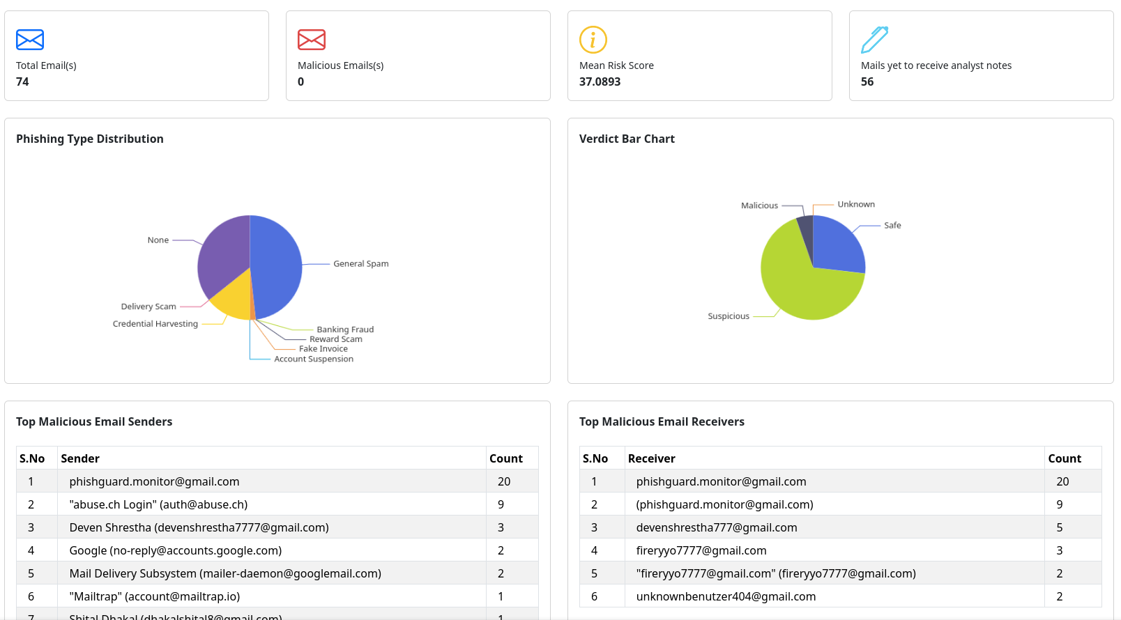
Figure 4.4.2.1Analyst Dashboard interface.
2. User Management Interface
The User Management interface enables administrators to manage system users efficiently. It displays registered users in a structured table containing essential information such as username, email address, and assigned role. Administrators can create new user accounts, modify existing user information, or remove users when necessary. This interface supports effective administration while maintaining secure role-based access control.
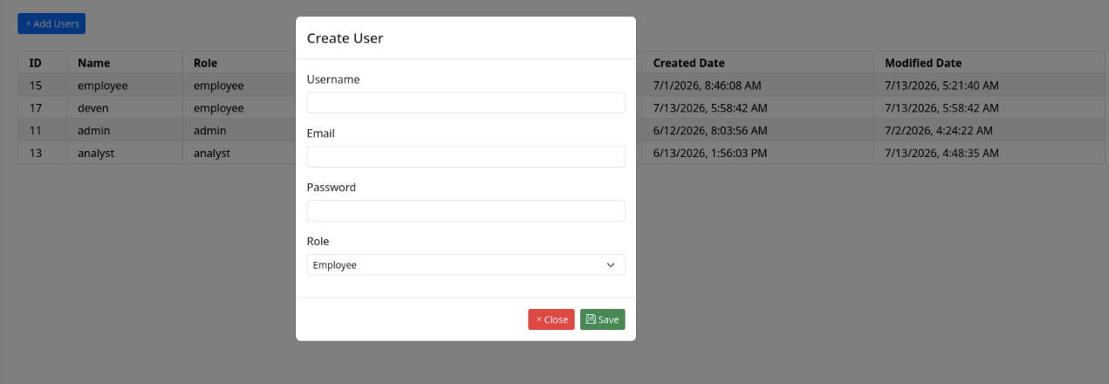
Figure 4.4.2.2 User Management interface.
3. Dashboard Visualization
The Dashboard Visualization screen presents summarized security statistics using interactive charts and graphical reports. Users can monitor phishing trends, threat distributions, severity levels, and overall system activity through visual representations, enabling faster understanding of the organization's email security posture.
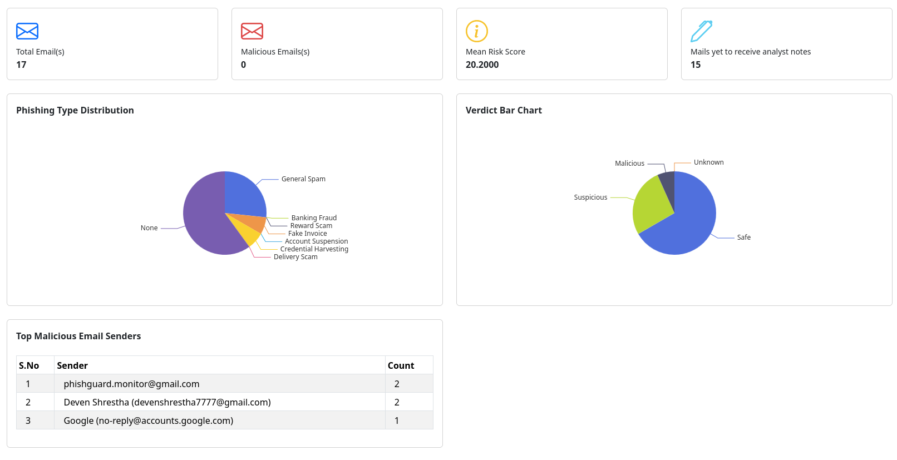
Figure 4.4.2.3 Dashboard interface.

4.5 Summary
In summary, the design phase of PhishGuard transforms the system requirements into a structured technical blueprint that guides the implementation process. The system adopts Django's Model-View-Template (MVT) architecture together with a well-designed relational database to ensure modularity, data integrity, and efficient system operation. The responsive user interface provides an intuitive environment for employees, security analysts, and administrators to interact with the system effectively. Overall, these design decisions establish a solid, secure, and maintainable foundation for the implementation and testing phases discussed in Chapter 5.

CHAPTER 5: IMPLEMENTATION AND TESTING

5.1 Implementation Approaches
This section describes the technologies, frameworks, and tools used to implement the PhishGuard system. The selected technologies provide a secure, scalable, and efficient environment for developing a web-based phishing email analysis platform. Each technology was chosen based on its suitability for cybersecurity applications, machine learning integration, database management, and responsive web development.
- Python 3.13+ (Programming Language): Python 3.13+ was selected as the primary programming language because of its simplicity, readability, and extensive ecosystem of libraries for cybersecurity, data analysis, and machine learning. It provides built-in support for email parsing, API integration, and automation, making it well suited for implementing the email analysis pipeline.
- Django 6.x (Web Framework): Django 6.x was chosen as the backend web framework because it follows the Model-View-Template (MVT) architecture and provides built-in features such as Object-Relational Mapping (ORM), authentication, session management, URL routing, and security protection against common web attacks. These features reduced development time while improving maintainability and security.
- PostgreSQL 18+ (Database Management System): PostgreSQL 18+ was selected as the relational database management system due to its reliability, performance, and strong support for relational data. It efficiently stores user information, email records, attachments, extracted Indicators of Compromise (IOCs), and analysis reports while maintaining data integrity through foreign key relationships.
- Scikit-learn 1.9+, Pandas 3.0+, and NLTK 3.9+: These libraries were used to implement the machine learning and natural language processing components of the system.
- Scikit-learn 1.9+: Used to perform TF-IDF vectorization, train the Multinomial Naive Bayes model, and classify emails as legitimate or phishing.
- Pandas 3.0+: Used for loading, cleaning, preprocessing, and analyzing the phishing email dataset during the model training phase.
- NLTK 3.9+: Used for text preprocessing tasks, including tokenization, stop-word removal, and stemming before machine learning classification.
- Bootstrap 5, jQuery, Apache ECharts, SweetAlert2, and Toastr: The frontend interface was developed using modern web technologies to provide a responsive and interactive user experience.
- Bootstrap 5: Used to build a responsive and consistent user interface across different screen sizes.
- jQuery: Used to simplify client-side scripting, AJAX requests, and dynamic page interactions.
- Apache ECharts: Used to generate interactive charts for visualizing phishing trends, threat categories, severity distributions, and other security statistics.
- SweetAlert2: Used to display confirmation dialogs and interactive alert messages during user operations.
- Toastr: Used to display lightweight notification messages for successful operations, warnings, and errors.

5.2 Coding Details and Code Efficiency
This section highlights two important implementation components of the PhishGuard system. Instead of presenting the complete source code, only the key algorithms responsible for email threat detection and system optimization are discussed.

5.2.1 Dynamic Risk Scoring Algorithm
One of the core components of PhishGuard is the weighted risk scoring engine. Rather than relying on a single detection method, the system combines the results from multiple analysis modules, including email authentication, phishing keyword detection, threat intelligence lookups, and machine learning classification. The algorithm dynamically adjusts the weight assigned to each module depending on whether malicious Indicators of Compromise (IOCs) are detected. This approach improves detection accuracy while reducing false positives.
Code Snippet: Dynamic Risk Scoring Logic
if ioc > 0:
raw_score = auth + ioc + keywords + (ml * 0.20)
else:
raw_score = (auth * 1.2) + (keywords * 1.6) + (ml * 0.40)
return min(max(int(round(raw_score)), 0), 100)
When malicious IOCs are present, the algorithm assigns greater importance to IOC evidence while reducing the influence of the machine learning score. If no malicious IOCs are detected, the algorithm increases the contribution of authentication analysis, keyword detection, and machine learning to calculate the final risk score.

5.2.2 IOC Caching Strategy
To minimize unnecessary API requests and remain within the rate limits of external threat intelligence services, PhishGuard implements a local IOC caching mechanism. Before querying external services such as VirusTotal or AbuseIPDB, the system first checks whether the same IOC has already been analyzed. If a cached result is available, it is reused immediately.
Code Snippet: IOC Cache Lookup
cached_mal, cached_score, found = get_cached_ioc_result(
ioc.ioc_type,
ioc.value
)
if found:
is_malicious = cached_mal
score = cached_score
This strategy significantly reduces external API requests, decreases response time, and improves overall system performance.

5.2.3 Code Efficiency
Several optimization techniques were implemented to improve the performance and resource utilization of the PhishGuard system.
- Model Loading Optimization: The machine learning model and TF-IDF vectorizer are loaded only once and reused throughout the application's execution, avoiding repeated disk access.
- IOC Result Caching: Previously analyzed Indicators of Compromise are retrieved from the local database instead of repeatedly querying external threat intelligence APIs, reducing network traffic and API usage.
- Conditional API Requests: External API calls are made only when an IOC is not available in the local cache, helping the system stay within API rate limits.
- Efficient Database Queries: Django ORM filtering and indexed database fields are used to retrieve only the required records, improving query performance during email analysis and report generation.
- Modular Service Architecture: The application is divided into independent service modules such as email parsing, header analysis, IOC extraction, keyword detection, machine learning classification, and risk scoring. This modular approach improves maintainability, code reuse, and future scalability.

5.3 Testing Approach
The PhishGuard system was tested using a bottom-up testing approach, where individual modules were verified independently before being integrated into the complete email analysis pipeline. This approach helped identify defects at an early stage and ensured that each module functioned correctly before interacting with other components. The testing process consisted of Unit Testing, Integration Testing, and Beta Testing to evaluate the system's functionality, reliability, and overall performance.

5.3.1 Unit Testing
Unit testing was performed to verify the correctness of individual modules and functions developed for the system. Each module was tested independently using different input scenarios to ensure that it produced the expected output.
- Header Authentication Testing: The email authentication module was tested using different combinations of SPF, DKIM, and DMARC results to verify that authentication scores were calculated correctly.
- Machine Learning Preprocessing Testing: The text preprocessing module was tested using emails containing uppercase letters, punctuation, HTML content, and special characters to ensure that tokenization, stop-word removal, and stemming were performed correctly before classification.
- Risk Scoring Testing: The risk scoring module was tested using normal, boundary, and invalid input values to verify that the calculated risk score always remained within the range of 0 to 100 and produced the correct security verdict.

5.3.2 Integration Testing
Integration testing was performed to verify that all modules communicated correctly and exchanged data without errors.
- Email Processing Pipeline: The complete email analysis workflow was tested to ensure that retrieved emails were successfully parsed, analyzed, classified, and stored in the database.
- Threat Intelligence Integration: The system was tested to verify that extracted Indicators of Compromise (IOCs) were correctly processed and checked against external threat intelligence services before updating the final analysis report.
- Dashboard Integration: The interaction between the backend services and the web interface was tested to ensure that analysis results, risk scores, and reports were displayed correctly and updated immediately after processing.

5.3.3 Beta Testing
A User Acceptance Testing (UAT) phase was conducted to evaluate the usability and stability of the system in a simulated organizational environment.
Two user accounts representing an Employee and a Security Analyst were created. A collection of legitimate emails, spam messages, and phishing emails containing suspicious links and attachments was submitted to the system. The testers verified that emails were analyzed successfully, appropriate risk scores and verdicts were assigned, and the generated reports were displayed correctly on both the employee dashboard and the analyst dashboard. Feedback collected during this phase was used to correct minor issues and improve the overall user experience.

5.4 Modifications and Improvements
During the implementation of PhishGuard, several modifications were made to the original system design to address technical challenges, improve system performance, and enhance the overall functionality of the application.

5.4.1 Optimized Threat Intelligence Lookup
- Technical Challenge: The initial design planned to query external threat intelligence services for every extracted Indicator of Compromise (IOC). During implementation, this approach resulted in unnecessary API requests and was constrained by the rate limits of free-tier services, causing delays in the email analysis pipeline.
- Modification/Improvement: A local IOC caching mechanism was introduced to store the results of previously analyzed indicators. Before sending an external request, the system first checks whether the IOC already exists in the local database. Cached results are reused immediately, while only new IOCs are sent to external threat intelligence services. This optimization significantly reduced API usage, improved response time, and enhanced the overall efficiency of the email analysis process.

5.4.2 Enhanced Risk Scoring Strategy
- Technical Challenge: The original design used fixed weights for combining the outputs of different detection modules. During testing, it was observed that assigning equal importance to every detection method occasionally produced inaccurate risk scores and increased false-positive classifications.
- Modification/Improvement: The risk scoring engine was redesigned to use a dynamic weighted scoring strategy. When malicious Indicators of Compromise (IOCs) are detected, the system gives greater importance to IOC evidence. When no malicious IOCs are present, higher weight is assigned to email authentication, phishing keywords, and machine learning classification. This adaptive approach improved the accuracy of the final risk score while reducing false-positive detections.

5.4.3 Machine Learning Model Improvement
- Technical Challenge: The initial machine learning model was trained on a relatively small dataset, limiting its ability to identify diverse phishing patterns and affecting the overall classification performance.
- Modification/Improvement: The model was retrained using a larger and more balanced phishing email dataset. Additional preprocessing techniques, including tokenization, stop-word removal, and stemming, were incorporated before TF-IDF feature extraction and Naive Bayes classification. These improvements increased the model's classification accuracy and enabled more reliable phishing detection.

5.5 Test Cases
To verify that the PhishGuard system functions correctly, a series of test cases were performed on the major system modules. The following table presents the testing scenarios, expected results, actual results, and execution status.
Table 5.5.1 – Core Module Test Cases
Test ID | Module | Scenario | Expected Result | Actual Result | Status
TC_01 | Accounts | User attempts to register with an already registered email address. | System displays "Email already exists" and prevents registration. | Displayed "Email already exists" message and registration was rejected. | Pass
TC_02 | Auth | User logs in with valid credentials. | User is authenticated and redirected to the dashboard. | User logged in successfully and dashboard loaded correctly. | Pass
TC_03 | Mailbox | New email is received in the monitored mailbox. | System retrieves and stores the email successfully. | Email was retrieved, parsed, and stored successfully. | Pass
TC_04 | Analysis | User analyzes an email containing suspicious URLs. | System analyzes the email and checks the IOC reputation. | Email analysis completed and IOC reputation was verified. | Pass
TC_05 | Analysis | User analyzes email containing phishing-related content. | System classifies the email and generates a risk score. | Email was classified as Phishing and the risk score was generated successfully. | Pass
TC_06 | Analysis | Email contains multiple phishing indicators. | System calculates the final risk score and assigns a verdict. | Email was marked Malicious with the correct risk score. | Pass
TC_07 | Reports | Security Analyst opens an analysis report. | System displays the complete analysis report. | Report displayed successfully with all analysis details. | Pass
TC_08 | Dashboard | Security Analyst opens the dashboard. | Dashboard displays updated statistics and recent reports. | Dashboard loaded successfully with updated charts and reports. | Pass
CHAPTER 6: RESULTS AND DISCUSSION

6.1 Test Reports
The execution of the test cases across the modular and integrated pipeline yielded highly positive results, demonstrating the stability, reliability, and correctness of the PhishGuard application.
The execution of the core test cases defined in Chapter 5 resulted in a successful pass rate. During the early stages of development and integration testing, a few minor issues were identified. These included a parsing exception in email_parser.py when processing inline attachments without standard Content-Disposition headers, and HTTP 429 (Too Many Requests) responses from the VirusTotal API during large-scale concurrent email analysis.
These issues were successfully debugged and resolved before the final release of the system. The email parser was enhanced by implementing a regular expression (regex) fallback mechanism to improve attachment parsing, while the threat intelligence module was optimized through the implementation of a cascading lookup strategy that combines local database caching with specialized threat intelligence APIs. This approach significantly reduced unnecessary external API requests and effectively mitigated API rate-limit constraints.
Following these improvements, all core test cases were executed successfully. The backend handled concurrent email ingestion tasks reliably, and the Django application maintained consistent database transactions throughout the analysis pipeline. The system operated without database deadlocks or data inconsistency during testing, demonstrating its stability under normal operating conditions.

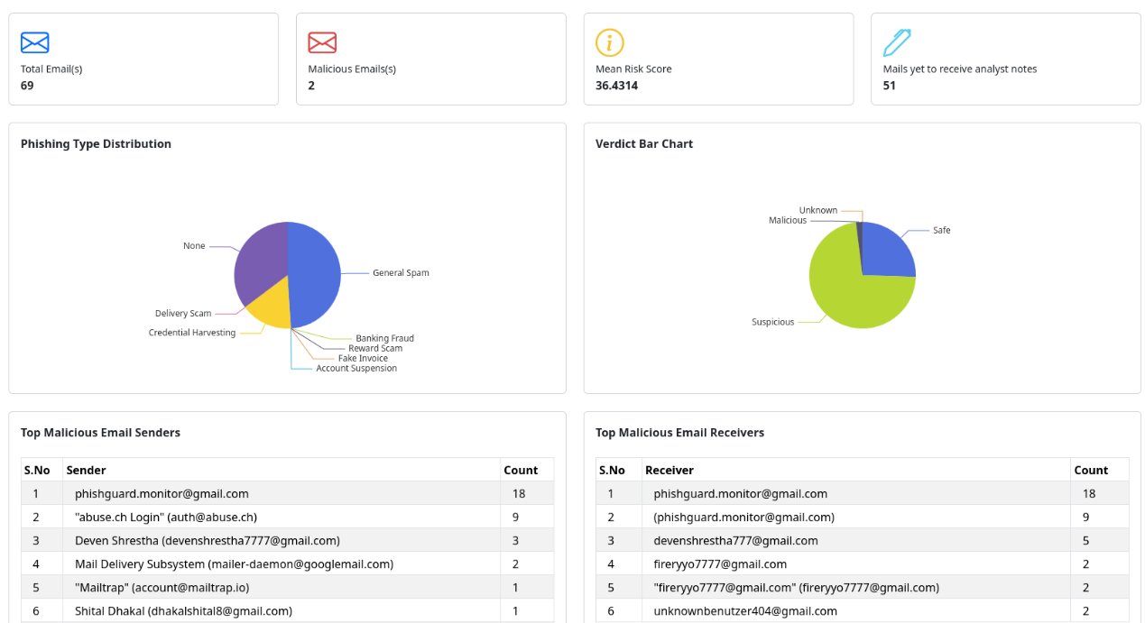
Figure 6.1.1 - Final Analyst Threat Operations Dashboard UI
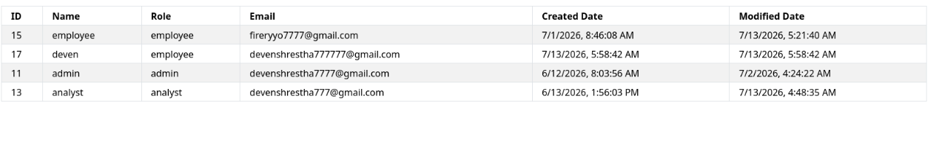Figure 6.1.2 - Admin User Governance Dashboard UI

6.2 User Documentation
This section provides a brief user guide for the primary functions of the PhishGuard system. The documentation is divided into two user roles: Employees and Security Analysts.

6.2.1 Guide for Employees: Verifying Email Security
- Login: Open the PhishGuard web application portal. Enter your your assigned organizational credentials username and password, then click the Login button.
- Access the Dashboard: After successful authentication, you will be redirected to the Employee Dashboard, where all analyzed emails associated with your account are displayed.
- Check the Email Status: Locate the email you wish to inspect and review its security status:
  - Safe (Green): The email has been verified and does not contain suspicious indicators.
  - Suspicious (Yellow): The email contains potential security concerns and should be reviewed carefully.
  - Malicious (Red): The email has been identified as a phishing or malicious email.
- View Analysis Details: Click on the desired email to view its detailed analysis report, including the overall risk score, verdict, and summary of the detected security indicators.

6.2.2 Guide for Security Analysts: Investigating Email Threats
Security analysts use the admin-level features of PhishGuard to monitor operations, verify IOC reputations, and update risk score outcomes:
- Login: Access the PhishGuard application using your Security Analyst credentials.
- Open the Dashboard: After logging in, the Analyst Dashboard displays recent email analysis results, threat statistics, and security charts.
- Review Email Reports: Select the Email Data menu to view the list of analyzed emails. Choose an email to open its detailed analysis report.
- Analyze Threat Information: Review the extracted indicators, authentication results, risk score, machine learning classification, and threat analysis summary provided by the system.
- Update the Report: If necessary, modify the risk score, add investigation notes, or update the verdict. Click the Update button to save the changes.
- Monitor Security Trends: Return to the dashboard to review updated charts and statistics showing phishing trends, threat categories, and overall system activity.

CHAPTER 7: CONCLUSIONS

7.1 Conclusion
The development of the PhishGuard email analysis and security visualization platform successfully achieved its primary objective of transforming manual, time-consuming email threat analysis into an automated and intelligent security workflow. By leveraging the Django framework and PostgreSQL relational database, the project delivered a secure, reliable, and user-friendly platform for detecting and analyzing phishing emails.
The application automates email retrieval through IMAP, analyzes email authentication mechanisms (SPF, DKIM, and DMARC), extracts Indicators of Compromise (IOCs), verifies suspicious indicators using external threat intelligence services, classifies email content using a Multinomial Naive Bayes machine learning model, calculates an overall risk score, and presents the analysis through an interactive web dashboard. These capabilities satisfy the objectives defined in Chapter 1 and demonstrate that combining machine learning with multi-layered threat analysis provides an effective approach for identifying phishing attacks and other email-based security threats.

7.1.1 Significance of the System
The significance of PhishGuard lies in its ability to automate the identification and analysis of suspicious emails, reducing the time and effort required for manual investigation. Instead of manually inspecting email headers and verifying suspicious links using multiple external security services, security analysts are provided with a centralized platform that generates risk scores, detailed analysis reports, and extracted Indicators of Compromise. In addition, the system provides employees with clear security verdicts for received emails, helping improve security awareness and reducing the risk of credential theft, business email compromise, and malware infections within an organization.

7.2 Limitations of the System
Despite the successful implementation and functional verification of the system, the current version of PhishGuard has several limitations.
- API Key and Quota Dependencies: The threat intelligence module depends on external services such as AbuseIPDB, Google Safe Browsing, and VirusTotal for reputation analysis. If these services become unavailable, API keys expire, or free-tier request limits are exceeded, the system cannot perform real-time reputation verification and instead relies on previously cached results.
- Internet Connectivity Requirement: PhishGuard requires a stable internet connection to retrieve emails from the monitored mailbox through IMAP and to communicate with external threat intelligence services. As a result, the system cannot perform real-time email analysis or reputation lookups in offline or isolated network environments.
- Static Machine Learning Model: The machine learning classifier is trained offline using the Zero-Day Phishing Emails Corpus. Although it provides high detection accuracy, the model does not automatically learn from newly emerging phishing techniques. Detecting new attack patterns requires the model to be retrained and redeployed.
- Lack of Dynamic Sandbox Analysis: The system verifies attachments by checking their cryptographic hashes against external threat intelligence databases. However, it does not execute attachments within an isolated sandbox environment to observe their runtime behavior. Consequently, newly developed malware with no existing reputation records may not be detected through attachment analysis alone.

7.3 Future Scope of the Project
The modular architecture of PhishGuard provides a strong foundation for future enhancements and feature expansion. The following improvements could be implemented in future versions of the system to enhance its functionality, scalability, and effectiveness in detecting email-based cyber threats.
- Docker-Based Deployment: The current version of PhishGuard requires manual installation and configuration of the development environment. A future version could package the application using Docker containers, allowing the web application, database, and background services to be deployed through a single configuration. This would simplify installation, improve portability, and make deployment easier across different operating systems and cloud environments.
- Active Attachment Sandboxing: At present, the system verifies email attachments by checking their reputation through external threat intelligence services. A future enhancement could integrate sandbox technologies such as Cuckoo Sandbox or Any.Run to execute suspicious attachments within an isolated virtual environment. This would enable the detection of previously unknown malware based on its runtime behavior rather than relying solely on existing reputation databases.
- Real-Time Email Gateway Protection: The current implementation analyzes emails after they have been delivered to the monitored mailbox. A future version could function as an SMTP email gateway that inspects incoming emails before they reach users' inboxes. Suspicious or malicious emails could then be quarantined automatically, preventing users from interacting with them.
- SIEM Integration: Future versions could integrate with enterprise Security Information and Event Management (SIEM) platforms such as Splunk, Elastic SIEM, or IBM QRadar. This would allow detected threats, Indicators of Compromise (IOCs), and risk alerts to be forwarded automatically to centralized monitoring systems, improving incident response and organizational security monitoring.
- MISP Threat Intelligence Integration: PhishGuard could be integrated with the Malware Information Sharing Platform (MISP) to enable automated sharing of threat intelligence. Newly identified phishing URLs, malicious IP addresses, domains, and file hashes could be shared with other organizations, while community threat feeds could also be imported to strengthen the system's detection capabilities.
- Automated Phishing Takedown Reporting: A future enhancement could enable the system to automatically report confirmed phishing websites and malicious domains to services such as Google Safe Browsing, PhishTank, OpenPhish, and national Computer Emergency Response Teams (CERTs). This would allow PhishGuard to contribute not only to threat detection but also to the removal of phishing infrastructure from the internet.

REFERENCES
abuse.ch. (2026a). MalwareBazaar API documentation. https://bazaar.abuse.ch/api/
abuse.ch. (2026b). URLhaus API documentation. https://urlhaus.abuse.ch/api/
Anti-Phishing Working Group (APWG). (2024). Phishing activity trends report: 4th quarter 2023 / 1st quarter 2024. APWG. https://apwg.org/trendsreports/
Chiew, K. L., Chang, E. H., Sze, S. N., & Abdullah, J. (2018). A survey on domain name system (DNS) security and phishing detection. Journal of Network and Computer Applications, 102, 11-28. https://doi.org/10.1016/j.jnca.2017.11.002
eSewa. (2024). eSewa merchant integration developer guide. eSewa Developer Documentation. https://developer.esewa.com.np/
Google Cloud. (2023). Google Safe Browsing: API v4 developer guide. Google Developer Documentation. https://developers.google.com/safe-browsing/v4
KnowBe4. (2024). PhishER product specifications and incident response guide. KnowBe4 Support Documentation. https://support.knowbe4.com/hc/en-us/articles/360012431414-PhishER-Product-Manual
Kumaran, S., Saini, A., & Gupta, S. (2017). Deep learning for email spam and phishing classification. International Journal of Computer Applications, 164(8), 22-29. https://doi.org/10.5120/ijca2017913745
Nightingale, J. (2017). Deceptive domain names: Social engineering in modern phishing campaigns. SANS Institute Information Security Reading Room. https://www.sans.org/white-papers/37920/
Shaukat, M. (2024). Zero-day phishing emails corpus [Data set]. Kaggle. https://www.kaggle.com/datasets/mutahirshaukat/zero-day-phishing-emails-corpus
Statista. (2024). Number of sent and received emails per day worldwide from 2017 to 2027. Statista Research Department. https://www.statista.com/statistics/273476/number-of-emails-sent-per-day-worldwide/
VirusTotal. (2026). VirusTotal API v3 documentation. https://docs.virustotal.com/reference

